Online Diary – Joshua Baker

13/10/20

A list of the names of the members of the design and play testing teams.

Just like last week I was given the task to create a game in groups of 3-4. I joined (Ben Miller, Sienna Jenkins and Stefan-Alexandru Zarnescu) for this group and we were tasked to create a game that is based around territory, we were given the option to have a historical theme too. The mechanics of the game are single player conflict for complete conquest/ control of the board.

The Games rules:

Each player assigns themselves a colour, they then place 2 tiles of that colour anywhere on the outside of the board, and any other tiles must be placed next to the same colour.

The game itself is played within 10 turns overall, and within each turn each player can place two extra tiles on the board.

Players can place 2 tiles over different players tiles if the tiles they are placing are close to their own

Each hexagon is worth more as it gets towards the centre, so outer hexagons are worth less than hexagons in the centre of the board.

Although we could not use any physical material we did use some programs to help us make our game, for example we used paint for our board, that way then players could input their colours by filling in a tile on the board.

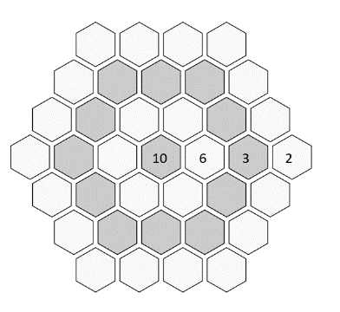Here is the board I created together with my team.

As you can see, players place 2 counters by filling in the hexagon with their colour (using paint fill tool) The aim for all the players is to occupy the most inner hexagon tiles as they are worth more points.

We learnt a lot from play testing, even though we could not play test with other groups due to lack of time we selected our 4th member (Stefan-Alexandru Zarnescu) to focus on play testing. As we play tested we found some loop holes in the rules that we needed to patch out, for example the rule (Players can place 2 tiles over different players tiles if the tiles they are placing are close to their own) was placed after play testing because Stefan found players could place tiles anywhere which is not what we wanted.

My experience working in this team was much better than last week, partly due to the fact that we were face to face this week but also because we had an extra member which was a lot more useful. Peoples ideas and corrections when pitching the idea for this game was extremely valuable. I feel like I took more of a leadership role on this team which made me more comfortable, I was able to get the team together under the idea very fast, our communication was much better and it was just much easier to work with each other compared to being online. However, I feel like our presentation is the main thing that could have been improved.